ve

* **Central Equipment Identity Register Importer Portal**

**End User Manual v 2.1**

Document Change History

|  |  |  |  |
| --- | --- | --- | --- |
| Version | Change Type | Description | Date |
| Draft |  | Submitted for internal review | February 2020 |
| Version 2.0 |  | Multiple System Admin, Configurable Notifications, Filter and sorting, Field Validations, History of the request, Address management | June 2021 |

Contents

1 Overview 1

1.1 Scope 1

1.2 Acronyms & Abbreviations 1

1.3 Conventions 1

2 End User Operations 3

2.1 Application Overview 3

2.2 Accessing the Application 3

2.3 Check IMEI 4

2.4 Stock Management - Anonymous 5

2.5 Grievance Management 9

2.6 Registering Devices 13

2.7 Update Visa 23

Figures

Figure 1: CEIR Home Page 3

Figure 2: Check IMEI Page 4

Figure 3: Check IMEI Not Success Page 4

Figure 4: Check IMEI Success Page 5

Figure 5: Stock Page 5

Figure 6: Stock – Search Page 7

Figure 7: Stock – Check Upload Status Page 7

Figure 8: Grievance Page 10

Figure 9: Grievance Management - Search 11

Figure 10: Grievance Management - Details 12

Figure 11: Register Device 13

Figure 12: Register Device - Details 14

Figure 13: Add Device 14

Figure 14: Register Device 15

Figure 15: Register Device 18

Figure 16: Register Device 20

Figure 17: Update Visa - Search 23

Figure 18: Update Visa 23

Figure 19: Update Visa – Unregistered user 24

# Overview

## Scope

The objective of this manual is to help end user use the CEIR (Central Equipment Identity Register) application to raise grievances, check device, upload stock anonymously, register device and update visa details. The end user can be either the local Cambodian user or foreigner.

## Acronyms & Abbreviations

| **Acronym** | **Full Form** |
| --- | --- |
| CEIR | Central Equipment Identity Register |
| ESN | Electronic Serial Number |
| IMEI | International Mobile Equipment Identity |
| MEID | Mobile Equipment Identifier |
| PDA | Personal Digital Assistant |
| TAC | Type Allocation Code |
| TRC | Telecommunication Regulator of Cambodia |

## Conventions

| **Information** | **Convention** |
| --- | --- |
| UI elements  (such as names of windows, buttons, and fields) | Bold |
| References  (such as names of files, sections, paths, and  parameters) | *Italics* |
| **\*** | Indicates a mandatory field or column |

# End User Operations

## Application Overview

The CEIR (Central Equipment Identity Register) End User Portal application is used to perform the following tasks:

* Register Device – End user (both foreigner and Cambodian national user) can register the devices in the CEIR system when they bring devices while coming to Cambodia
* Upload stock – A Cambodian user can upload the stock anonymously in case any distributor/retailer does not want to register with the CEIR application
* Raise Grievance – A Cambodian user can raise the grievance in case they are facing any issue with CEIR system
* Check IMEI – End user can use this IMEI using this feature before buying the devices to check the validity of the devices
* Update Visa – End user can update visa details in case the duration of a foreigner user has been extended in Cambodia. This will allow the devices to be used till the visa expiry period.

## Accessing the Application

End user does not need to be logged into the system. The end user can access the CEIR system from DMC portal

To access various features:

1. Enter the CEIR Home Portal URL in the browser address bar. This opens the CEIR Home Portal page.

Figure 1: CEIR Home Page

1. Select the feature from the portal.

## Check IMEI

Check IMEI allow end user to check the validity of the device.

To check IMEI, click on the Check IMEI button the DMC portal page. The Check IMEI page appears

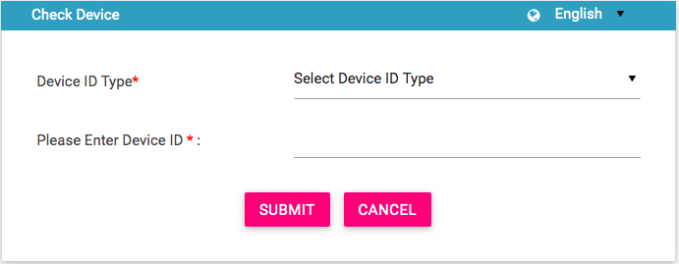

Figure 2: Check IMEI Page

On view of the Check IMEI, following information is displayed

1. Enter the following information:
   1. **Device ID Type**: Select the Device ID Type.
   2. **Please enter Device ID**: Enter the value of device ID which be checked.
2. Click **Submit**.

On click on submit, the Check IMEI result page appears

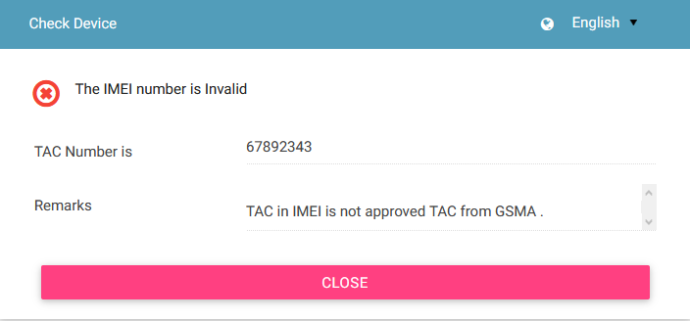

Figure 3: Check IMEI Not Success Page

In this scenario, the IMEI entered by user is not valid.

In case, when correct IMEI is provided, the following response is shown to the user.

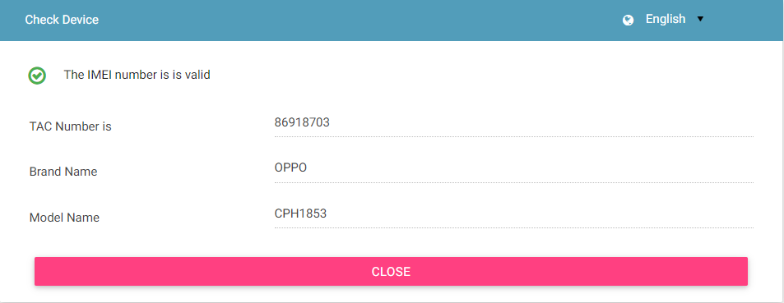

Figure 4: Check IMEI Success Page

## Stock Management - Anonymous

In case the distributor/retailer does not want to upload stock as a registered user, they have the option to upload the stock anonymously in grace period.

To upload stock:

1. Select “Upload Stock” from **Stock** menu on the DMC Home page

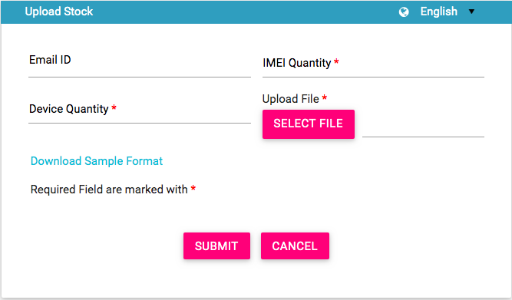

Figure 5: Stock Page

1. Enter the following information:
   1. **Email ID**: Enter the email ID. If the Email ID is provided, then the notification would be sent when the stock state change happens
   2. **\*IMEI Quantity**: Enter the total quantity of IMEIs
   3. **\*Device Quantity**: Enter the total quantity of devices.
   4. **\*Upload File**: Enter the IMEI details in a file. This is a **.csv** file with defined column names. You need to enter device information in this file. First, download the file format, if required.
   5. Click **Download Sample** **Format**.

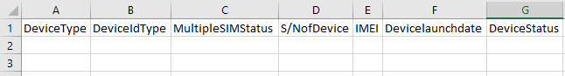

The file has the following columns:

* + **\*Device type**: The device can be a handheld phone, mobile phone, feature phone, smart phone, Vehicle, Portable (include PDA), Module, Dongle, WLAN router, modem, connected computer, tablet, e- Book.
  + **\*Device ID type**: Type can be IMEI (International Mobile Equipment Identity)
  + **\*Multiple SIM Status**: Number of multiple SIMs the device supports (1-4)
  + **\*S/N of** **Device**: Device serial number
  + **\*IMEI**: Value of IMEI
  + **Device launch** **date**: Launch date or manufacture date of the device (in the format, DDMMYYYY).
  + **Device status**: Whether the device is new or used (New/Used)
  1. Enter the required information in each column for each device.

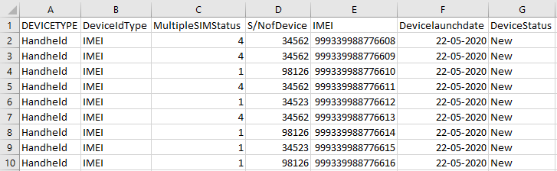

* 1. After you enter the device details, save the file.
  2. Click **SELECT FILE** to upload the file with all the details.

1. Click **SUBMIT**. A unique transaction ID is assigned to the uploaded stock.

Once the stock is uploaded, the stock will be processed in the CEIR system. If email ID is provided, the same is shared over email as well with the end user.

To check status of uploaded stock:

Select “Check Upload Status” from the Stock menu from the DMC portal page.

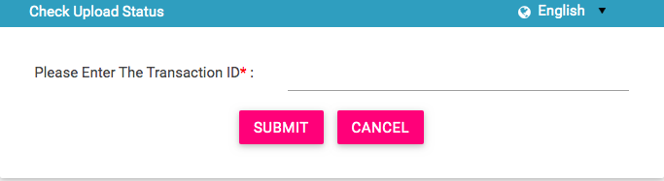

Figure 6: Stock – Search Page

Enter the Transaction ID and press Submit button. “Stock Page Appears”.

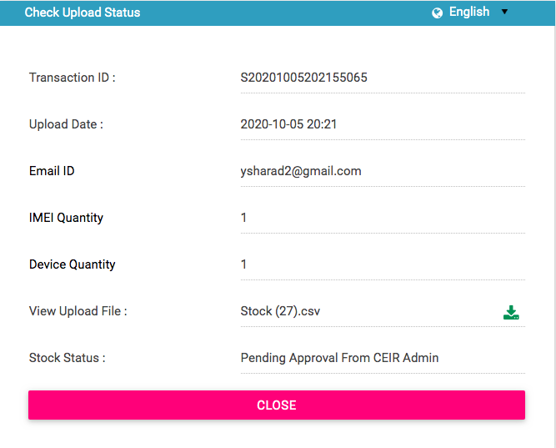

Figure 7: Stock – Check Upload Status Page

The following columns are displayed.

| **Column** | **Description** |
| --- | --- |
| Transaction ID | Transaction ID of the stock uploaded by user. |
| Upload Date | Date when the stock was uploaded by end user. |
| Email ID | Email ID of the end user. |
| IMEI Quantity | Denotes the number of IMEI in the file |
| Device Quantity | Denote the number of devices in the file |
| View Upload File | File name with an option to download the same. |
| Stock Status | The uploaded stock goes through different status modes.   * New: When the stock is uploaded, its status is **New**. * Processing: The stock is processed and validated. The status changes to **Processing**. * Rejected by System If the stock does not have valid information, an error file is generated. The importer can view the file and fix the errors in the consignment. * Approval Pending by CEIR Admin: The uploaded stock is available for review by the CEIR administrator. * Approved by CEIR Admin: The stock is approved by the CEIR administrator. * Rejected by CEIR Admin: The CEIR administrator reviews the details and rejects the stock if there is a problem. * Withdrawn by CEIR Admin: The CEIR administrator can withdraw stock. |

## Grievance Management

End user can register complaints or grievances when there is a problem in the portal. For example, there could be situations when a feature is not working like there could be a problem in uploading the stock.

When an end user raises a grievance, the grievance goes through the following stages:

1. A notification is sent to the CEIR administrator. The notification appears on the CEIR administrator portal. A mail is also sent to the registered mail of the CEIR administrator.
2. The CEIR administrator responds to the grievance. A response notification is sent to on the end user’s registered mail ID.
3. Steps 1 to 2 are repeated until the grievance is closed. The administrator closes the grievance.

There are situations when the grievance is automatically closed. A grievance is automatically closed when the status of the grievance changes to **Pending with User**, but there is no response from the importer for a specified period.

To raise a grievance

1. Select Report Grievance from **Register Grievance menu** in the DMC portal.

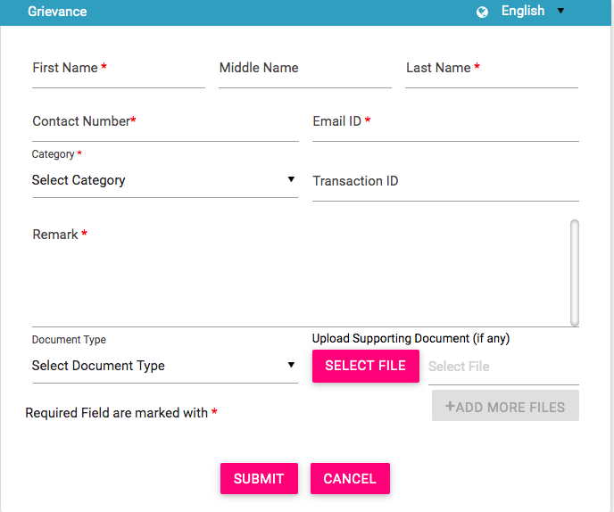

Figure 8: Grievance Page

1. The **Grievance Management** page appears.
2. Enter the following information:
   1. **First Name:** First name of end user
   2. **Middle Name:** Middle Name
   3. **Last Name:** Last Name
   4. **Contact Number:** Mobile Number
   5. **Email ID:** Email ID
   6. **Transaction ID**: Enter the transaction ID of the consignment if the grievance is related to a consignment or the transaction ID of the stock if the grievance is related to stock.
   7. **\*Category**: Select the category of the grievance. The options are:

* Consignment Related: Problem with registering consignment etc.
* Register Device Related: Problem with register device feature
* Stock Related: Problem with uploading stock etc.
* Other: Problem with any other aspect of the application
* Registration Related: Problem with registering information in the application.
  1. **\*Remarks:** Enter information about the grievance raised. This helps the administrator to understand the problem in detail.
  2. **Document Type:** Select the type of identification or another document that is to be uploaded. The options are:
* Passport
* Visa
* NID (National ID)
* Photo
* Other
  1. **Upload Supporting Document:** Click **Select File** to upload the document selected in **Document Type**.
  2. To upload more documents,click **+Add More Files.**

This adds two more fields: **Document Type** and **Select File**.

1. Click **SUBMIT**.

A grievance ID is generated and assigned to the registered grievance.

To check Grievance Status:

Select “Track Grievance” from the Report Grievance menu in the DMC home page. The Grievance page appear

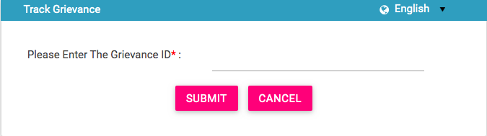

Figure 9: Grievance Management - Search

Once the user enters the grievance ID and press Submit button, the grievance details are shown

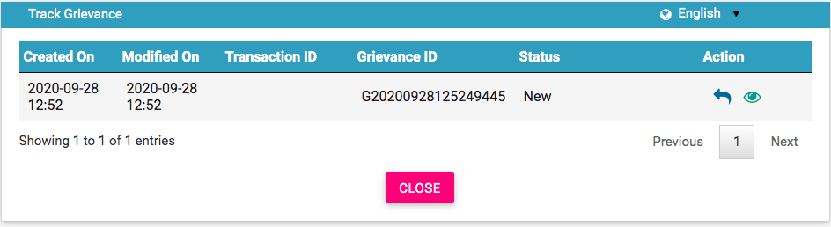

Figure 10: Grievance Management - Details

The following information is displayed on the page in case the grievance ID is found.

| **Column** | **Description** |
| --- | --- |
| Created On | Date of raising a grievance. |
| Modified On | The date when the grievance was modified. |
| Transaction ID | The transaction ID of stock or consignment for which a grievance was raised. |
| Grievance ID | This is the ID that is automatically assigned to the grievance. |
| Grievance Status | The uploaded grievance goes through different status modes.   * New: When a grievance is raised. * Pending with CEIR Authority: When a response is awaited from the CEIR administrator. * Pending with User: When a response is awaited from the importer. * Closed: When the CEIR administrator closes the grievance. |
| Action | This displays different actions that can be performed on a grievance.   * Reply : This is used to respond to the grievance. The response is given by the CEIR administrator or importer. The exchange of responses is done until the grievance is closed. * View A close up of a logo    Description automatically generated: This is used to view the grievance response history. The importer can see all the responses exchanged for any grievance. |

## Registering Devices

The custom officials use the CEIR application to register devices that are brought into Cambodia by foreigners/local Cambodian users. The registered device is used to build a device database. The end user has to pay taxes on the devices as per the applicable CEIR policy

To register a device:

1. The user needs to click “**Register Device**” in the DMC portal page.

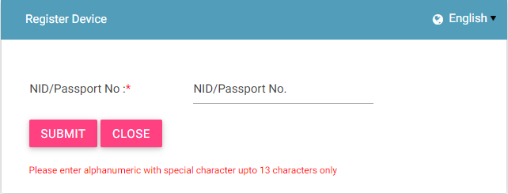

Figure 11: Register Device

1. Enter the NID/ passport number.
2. Click **Submit**.

If there are devices already registered with the passport number entered, the following page appears.

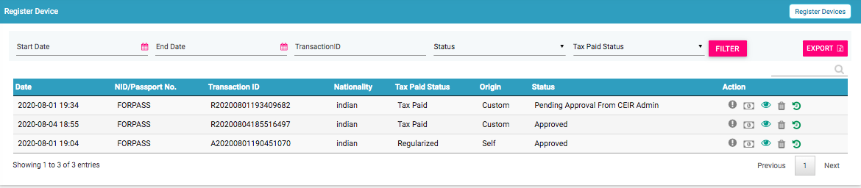

Figure 12: Register Device - Details

1. Click on Register Device button on top right. The following form opens up.

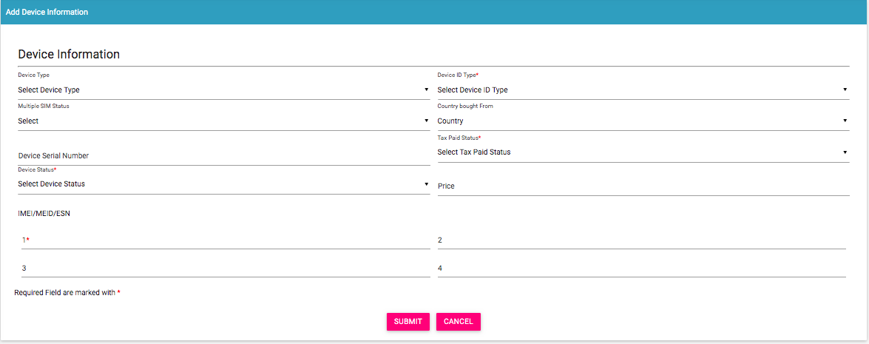

Figure 13: Add Device

1. Enter the following information:

* **Device Type**: Select the type of device:
  + Mobile Phone
  + Feature Phone
* \***Device ID Type**: Select the type of ID of the device that would be entered for identification:
  + IMEI
* **Multiple SIM Status**: Number of multiple SIMs the device supports multiple SIM slots (1-4)
* **Country bought from**: Select the country from where the device was bought.
* **Device Serial Number**: Enter the serial number of the device.
* \***Tax Paid Status**: Select the tax paid status
* **Price**: Price of the device
* \***Device Status**: Select the status of the device: New / Used
* **IMEI**: Enter the ID value(s). A maximum of 4 ID values can be entered.
* Click **Submit**.

A unique transaction ID is generated, and the request is processed internally. The registration request appears on top of the page.

If the passport number/NID is not found in the system and there is no device registered with the passport, the following page appears.

**For Cambodian Users:**

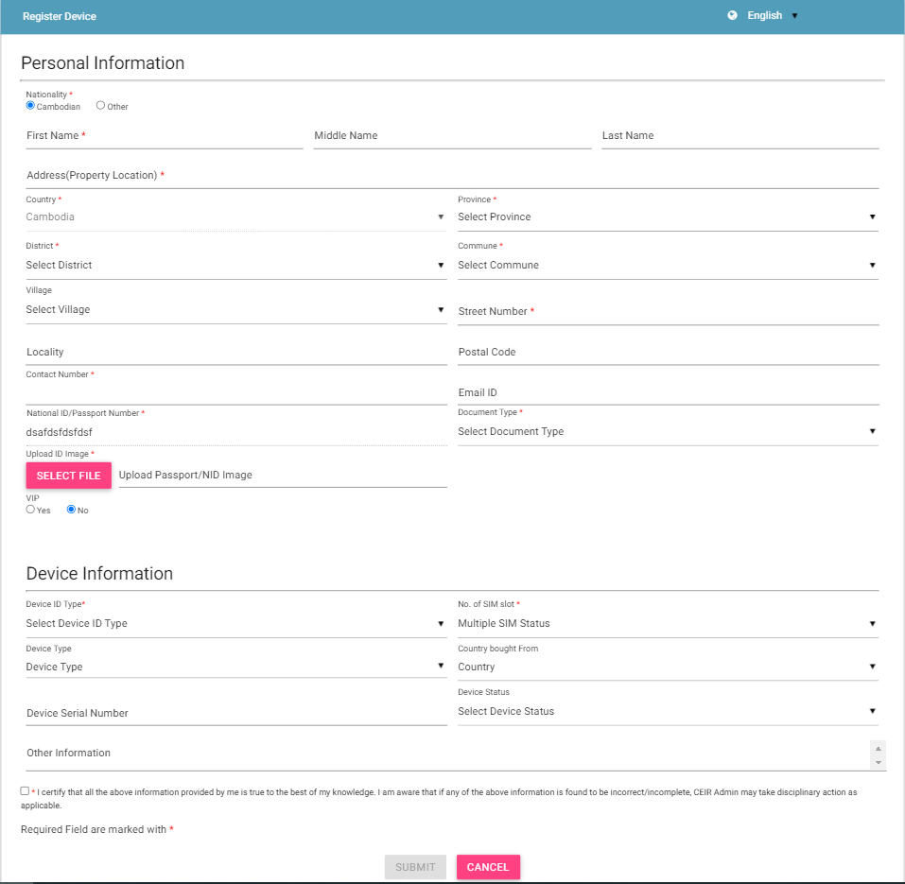

Figure 14: Register Device

Enter the following information:

**Personal Information:** Enter the personal details of the person.

* \***First Name**
* **Middle Name**
* **Last Name**
* \***Nationality**
* \***Address (Property Location)**
* \***Street Number**
* **Village**
* **Locality**
* \***District**
* \***Commune**
* **Postal Code**
* \***Country**
* \***Province**
* **Email ID**
* \***Contact Number**
* \***National ID/Passport Number**: Enter the National ID/ Passport Number.
* \***Document Type**: Select the type of document to be uploaded for identification.
  + Passport
* \***Select File**: Click to upload a PDF or image of the identification document.
* **VIP**: Select Yes or No depending on the status of the person.
  + Department Name: Enter the department of the person. This is applicable only if the person is a VIP.
  + Department ID: Enter the department ID of the person. This is applicable only if the person is a VIP.
  + Upload Department ID Image: Click File to upload an image of the department identification of the person. This is applicable only if the person is a VIP.
* **Device Information**: Enter details of the device.
* **Device Type:** Select Device type.
* \***Device ID Type**: Select the type of ID to be entered for the device:
  + IMEI
* **\*No of SIM Slots**: Number of multiple SIMs the device supports
* **Country Bought from:** Select the country
* **Device Serial Number:** Enter the serial number
* **Device Status:** Select the device status
* **IMEI**: Enter the value of the IMEIs of the device.
* Click **Submit**.

A unique transaction ID is generated, and the request is processed internally. The request can be seen on top of the page.

**For Non-Cambodian users:**

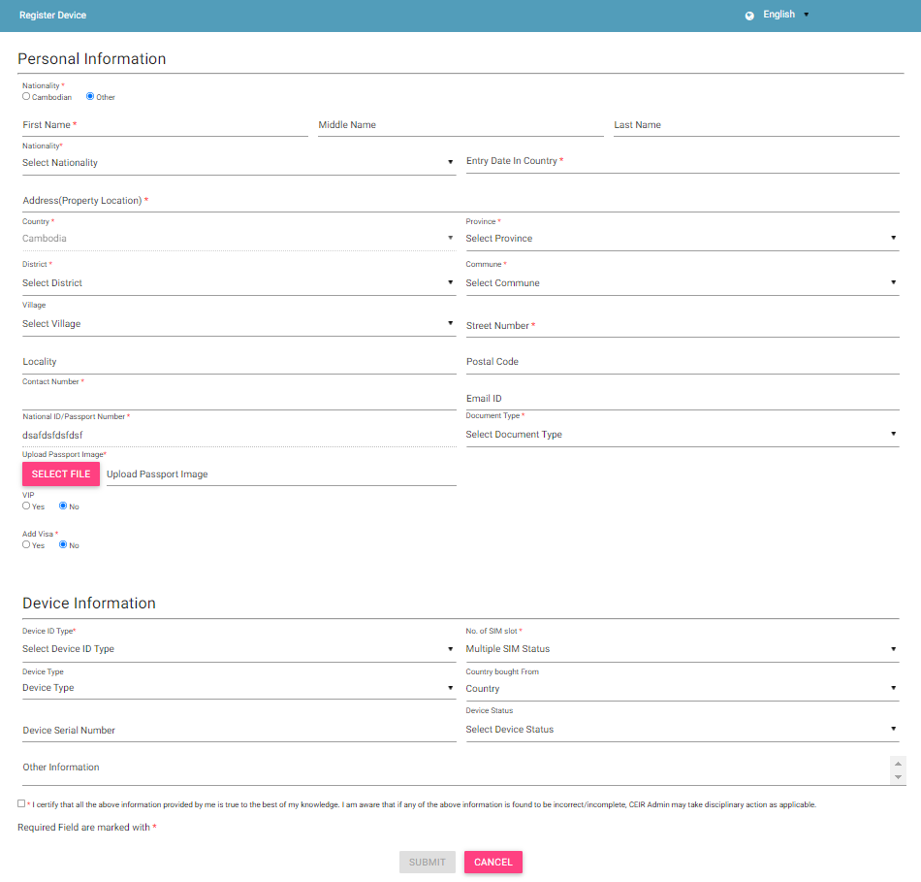

Figure 15: Register Device

Enter the following information:

**Personal Information:** Enter the personal details of the person.

* \***First Name**
* **Middle Name**
* **Last Name**
* \***Nationality**
* \***Entry Date in Country**: Select the date of entry in Cambodia.
* \***Address (Property Location)**
* \***Street Number**
* **Village**
* **Locality**
* \***District**
* \***Commune**
* **Postal Code**
* \***Country**
* \***Province**
* **Email ID**
* \***Contact Number**
* \***Passport Number**: Enter the passport number.
* \***Document Type**: Select the type of document to be uploaded for identification.
  + Passport
* \***Select File**: Click to upload a PDF or image of the identification document.
* **VIP**: Select Yes or No depending on the status of the person.
  + Department Name: Enter the department of the person. This is applicable only if the person is a VIP.
  + Department ID: Enter the department ID of the person. This is applicable only if the person is a VIP.
  + Upload Department ID Image: Click File to upload an image of the department identification of the person. This is applicable only if the person is a VIP.
* **Add Visa**: Select Yes or No depending on whether the person has a visa.
  + Visa Type: Select the type of visa. This is applicable only if the person has a visa.
  + Visa Number: Enter the visa number. This is applicable only if the person has a visa.
  + Visa Expiry Date: Select the expiry date of the visa. This is applicable only if the person has a visa.
  + Upload Visa Image: Click File to upload the visa image. This is applicable only if the person has a visa.
* **Device Information**: Enter details of the device.
  + *Device Type
* \***Device ID Type**: Select the type of ID to be entered for the device:
  + IMEI
* **Multiple SIM Status**: Number of multiple SIMs the device supports
* **Country Bought rom:** Select the country
* **Device Serial Number:** Enter the serial number
* **Device Status:** Select the device status
* **IMEI**: Enter the value of the IMEIs of the device.
* Click **Submit**.

A unique transaction ID is generated, and the request is processed internally. The request can be seen on top of the page.

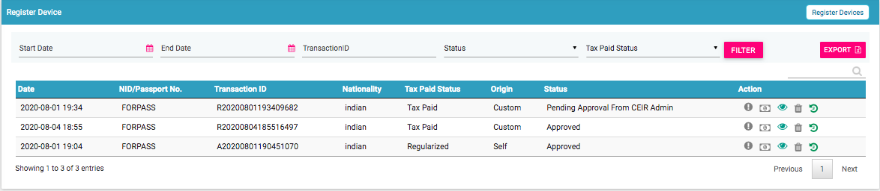

Figure 16: Register Device

For each request, the following information is displayed:

| **Column** | **Description** |
| --- | --- |
| Date | Date of registering the request. |
| Passport No/NID | Passport number/National ID |
| Transaction ID | Transaction ID assigned to the request. |
| Nationality | Nationality of the person entering Cambodia. |
| Tax Paid Status | Indicates whether tax has been paid for the device. |
| Origin | This indicates who has raised the request. The value can be   * End user * Immigration * Custom |
| Status | * The request goes through the following status modes:   + New: When a request is raised, the status is New.   + Processing: The request is verified internally.   + Rejected by System: If the request has an error, an error file is generated. The error file can be downloaded. The error could be in the file format, size, policy violation or request specifications.   + Pending Approval from CEIR Admin: If the request is successfully verified by the system, the request is shared with the CEIR administrator for review.   + Rejected by CEIR Admin: The CEIR administrator reviews the details and rejects the request if there is a problem. The official can view the error file and fix the errors in the request.   + Approved by CEIR Admin: When the CEIR administrator approves the request, the status changes to Approved by CEIR Admin. |
| Action | This displays different actions that can be performed on the request.   * Error : An error file is generated if there is any problem in the request(s) submitted. Click to download the error file. Refer to *Figure 18* for a sample error file. * Pay Tax : This is used to pay Tax of the device. Once the tax is paid, then tax paid status of device is changed to tax paid. * View : This is used to view the request. Click on it view the request details. * Delete : This is used to delete the request. This is allowed only when the request status is New or Rejected by System. Click on it to delete the request. * View History: This is used to view the history of the transaction. It shows the various status modes through which the transaction has gone through. |

## Update Visa

The foreigner user can upload the visa details in case the foreigner duration is extended in the Cambodia.

To update the visa details, click “Update Visa” in the DMC portal page.

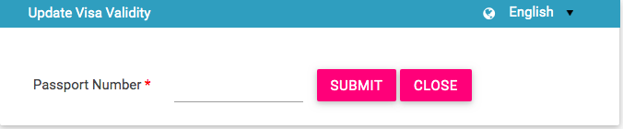

Figure 17: Update Visa - Search

Once when the end user enters the passport number, and click on Submit button, the following page appears in case the passport number is registered.

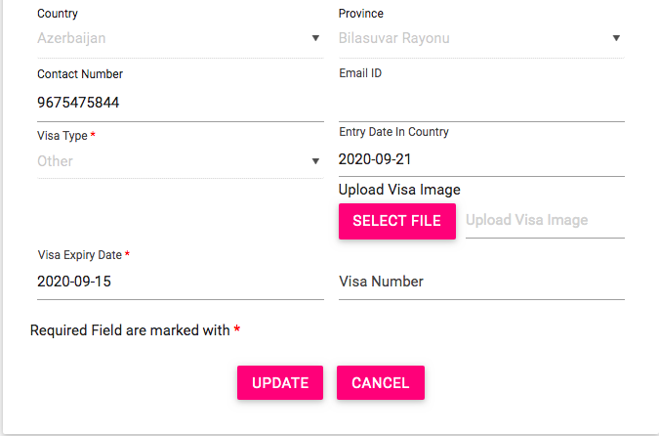

Figure 18: Update Visa

User can upload the visa details and click on the Update button

In case the user details are not found, then following page appears

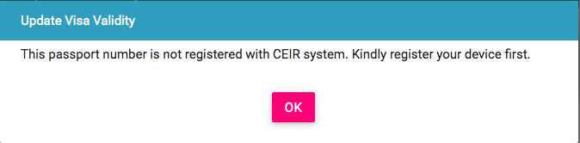

Figure 19: Update Visa – Unregistered user